Project Design Phase-II
Data Flow Diagram &amp; User Stories

Data Flow Diagrams
A Data Flow Diagram (DFD) is a traditional visual representation of the information flows within the BlogNest system. A neat and clear DFD can depict the right amount of the BlogNest system requirements graphically. It shows how data enters and leaves the BlogNest system, how the information is processed, and where the data is stored.

EXAMPLE:

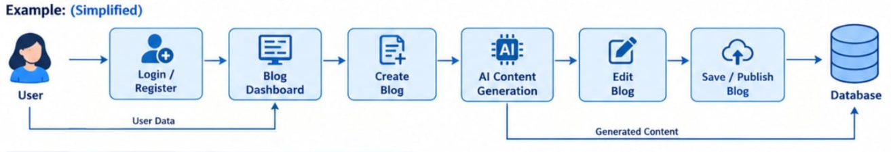
Key Flow Points:
  - User registers/logs in to the BlogNest application.
  - User selects a blog post to create, view, or edit.
  - BlogNest processes and stores the blog data.
  - User adds comments and interacts with blog posts.
  - BlogNest retrieves and displays the requested blog content to the user.
  - Admin manages users, blogs, and comments through the system.

User Stories
Use the below template to list all the user stories for the product.

